THE TWO BISHOPS
by
GM Bong Villamayor
Powerchess Asia

The two bishops are a strong force in both the middle game and the endgame; in most cases better than the different combinations of minor pieces. Their cooperation with the pawns giving them clear diagonals, the two bishops can create many motifs of achieving advantage. In some cases they thrive in semi closed positions.
They can support in the planning of an attack; they also restrict the movement of enemy pieces, taking away their good outposts; and because of their long-range capability it can be exchanged in a favorable moment to disrupt pawn structures.

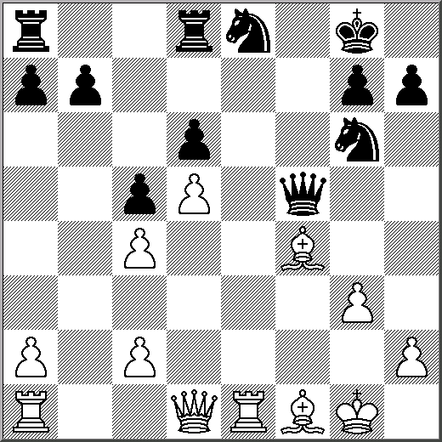
21.Bd3 Qf6 22.Bxg6! A characteristic turn; White relinquishes the Bishop pair but obtains in return either a weakening of the hostile pawn structure or else an inroad into the seventh rank 22...hxg6 [22...Qxg6 23.Re7 one advantage transformed into another] 23.Rb1 g5 [23...b6 24.Re6 Qd4+ 25.Qxd4 cxd4 26.Rd1 Rac8 27.Rxd4+-] 24.Be3 Rd7 25.Qg4 Rf7 26.Rf1 Qg6 27.Rxf7 Qxf7 28.Bxg5+- With a sound extra pawn, a good Bishop and some advantage in development White now stands to win 28...Nc7 29.Bf4 Qf6 30.Qd1 b6 31.Qd3 Re8 32.Rf1 b5 33.cxb5 Qd4+ 34.Qxd4 cxd4 35.Bxd6 Nxb5 36.Bb4 a5 37.Bxa5 Ra8 38.Bb4 Rxa2 39.d6 Ra8 40.d7 Nc7 41.Rf8++- 1-0
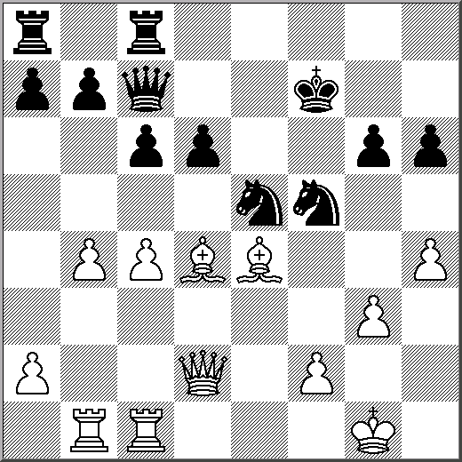
The undermining of support points in this position we see two centrally placed Bishops facing two centrally placed Knights. 1.Ba1 Preserving the Bishop from exchange [1.Bxf5?? Nf3+] 1...Rg8 [1...h5 2.Bxe5 dxe5 3.Bxf5 gxf5 4.Qg5+/-] 2.h5! Raf8 3.c5 Undercutting the other Knight as well 3...d5 Permits a decisive combination; but in any case the Bishops will now control the whole board 4.Bxd5+ cxd5 5.Qxd5+ Kf6 6.f4 Qc6 7.Bxe5+ Ke7 8.Bd6+ Nxd6 9.cxd6+ Qxd6 10.Re1+ Kd7 11.Qxb7+ Qc7 12.Rbd1# 1-0

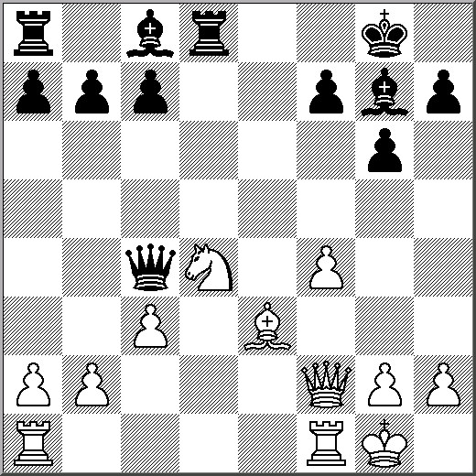
The systematic use of the Bishop pair: The plan is to deprive the opponent of such support points by means of pawn advances. The hostile pieces will thus be doomed to passivity, and the owner of the bishop pair should not find it difficult to set a decisive attack in motion. 1...c5 2.Nf3 b6 Puts an end to any Bishop activity on the g1-a7 diagonal 3.Ne5 Qe6 4.Qf3 Ba6 5.Rfe1 f6 deprives the Knight also of the e5 square 6.Ng4 h5 Drives the Knight further back 7.Nf2 Qf7 intending Bb7 inducing weaknesses on this diagonal 8.f5 white should strive for some counter play, but in so doing he only weakens his position. [8.b3] 8...g5 9.Rad1 Bb7 [9...Qxa2 10.Qxh5] 10.Qg3 Rd5! The f-pawn is now incurably weak [10...Qxa2 11.Qc7 Rxd1 12.Rxd1 Bd5 13.Qd7<=>] 11.Rxd5 Qxd5 12.Rd1 [12.Qh3? g4] 12...Qxf5 13.Qc7 Bd5 14.b3 Re8 15.c4 Bf7 16.Bc1 Re2 17.Rf1 Qc2 18.Qg3 [18.-- Rxf2 19.Rxf2 Qxc1+] 18...Qxa2 0-1

EXERCISES WITH THE TWO BISHOPS

1B 2W 3B
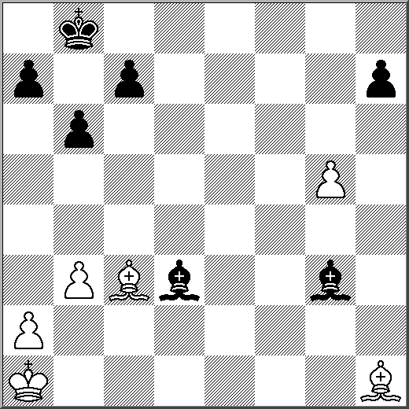
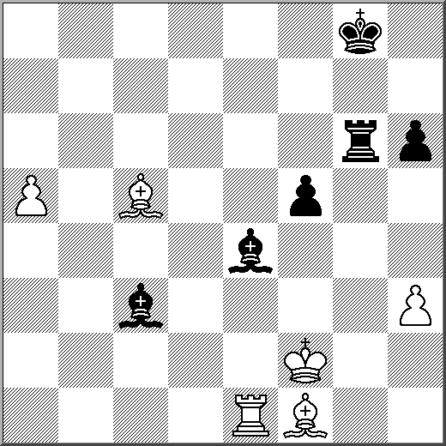
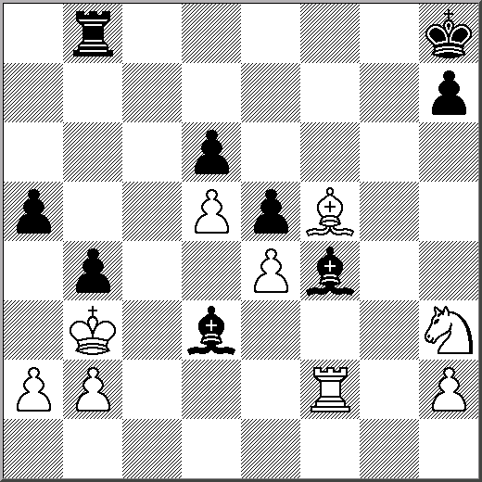

How does Black win pawn How to make use of the a-pawn Exploit the White King

4W 5W 6B
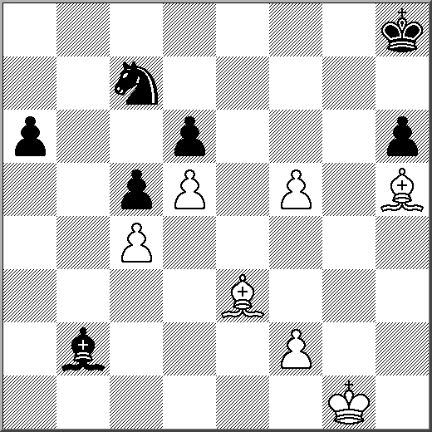
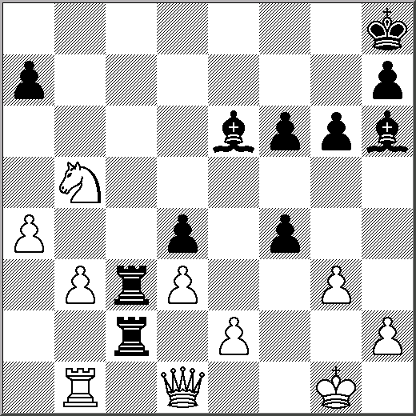
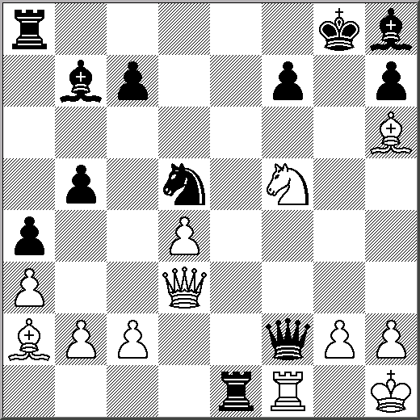

Find possible mate How to cramp Black’s pieces? Find the decisive threat
